***INTRODUCTORY FIELD GEOLOGY SUMMER 2025***

**UNM Department of Earth and Planetary Sciences**

**EPS 319L -- 4 credit hours, for Advanced Undergraduates**

**May 19 through June 9, 2025**

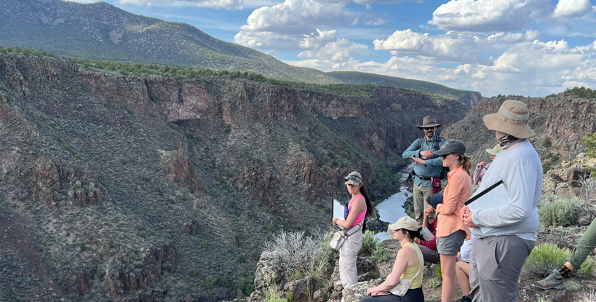

**Prerequisites**: mineralogy, petrology, sedimentology-stratigraphy, structural geology. **Expenses:** Course fee $450, tuition TBD based on UNM regents’ determination (2024 tuition was $1877 plus applicable fees). The EPS department provides a stipend for UNM EPS students taking the course; this stipend will at least cover the course fee with exact amount to be determined. **UNM students must complete and submit the field camp application form by April 4, 2025 at 4:00 pm.**

This course focuses on field investigation of the stratigraphy and structure of New Mexico rocks and landscape evolution. Using localities with spectacular exposure of interesting structures and landforms in western and northern New Mexico, projects begin at a basic level and expand in scope and geologic complexity as the course progresses. Students learn to collect and interpret field samples and data, prepare detailed maps, cross sections, and stratigraphic sections, synthesize data to answer a research question, and present their results and interpretations. Projects will involve camping, with students providing their own personal gear (tent, sleeping bag, etc.). Meals while camping will be provided via group cooking. Camping gear can be rented from the [UNM Outdoor Adventure Center](https://recservices.unm.edu/outdoor-adventure-center/index.html), and we will work to secure reduced cost gear rentals for students attending field camp.

**\*Field camp is an immersion experience (like taking an immersion language course); do not plan to work on other major activities during this period. \***

**For additional information email Dr. Tyler Mackey or Dr. Marisa Repasch**

[**tjmackey@unm.edu**](mailto:tjmackey@unm.edu) **or** [**mrepasch@unm.edu**](mailto:mrepasch@unm.edu)

**Tentative schedule** (beginning and end dates are set, but project dates may shift):

* **Course introduction - 2 days (May 19 - 20):** Introduction to field methods and geologic background. Based out of Albuquerque.
* **Western NM module - 5 days (May 21 – 25):** Rio Grande Rift and volcanic activity. Camping for 5 days/4 nights
* **Albuquerque day off (May 26 Memorial Day)**
* **Northern NM module** **– 9 days (May 27 – June 4):** Taos Plateau Volcanics and Rio Grande Gorge. Camping for 9 days/8 nights
* **Project synthesis – 5 days (June 5 – June 9):** you will choose one of our projects to expand upon with additional analyses and then create a research poster that will be presented during the final class session.

**APPLICATION FORM - INTRODUCTORY FIELD GEOLOGY, EPS 319L**

**University of New Mexico / Earth and Planetary Sciences**

**INSTRUCTIONS:**

* **Complete and save application form**
* **Obtain digital copies of unofficial transcript(s)**
* **Complete anonymous field camp planning survey:** [**https://forms.gle/gHRVqEmiSh96CeDFA**](https://forms.gle/gHRVqEmiSh96CeDFA)
* **Send application and transcripts by email to Cecilia Arias (epsdept@unm.edu) by the deadline April 4, 2025 by 4:00 pm.**

Name:

Address:

City:

State:

Phone Number(s):

Email:

Undergraduate GPA:

Prerequisite courses completed:

|  |  |
| --- | --- |
| **Course** | **Grade** |
| Mineralogy |  |
| Igneous-Metamorphic Petrology |  |
| Sedimentology Stratigraphy |  |
| Structural Geology |  |

**For additional information please email or call:**

**Dr. Tyler Mackey (**[**tjmackey@unm.edu**](mailto:tjmackey@unm.edu)**) or Dr. Marisa Repasch (**[**mrepasch@unm.edu**](mailto:mrepasch@unm.edu)**)**

**(505) 277-4204 (department front office)**

**Cecilia Arias (**[**epsdept@unm.edu**](mailto:epsdept@unm.edu)**)**

**Coordinator Education Support**

**Department of Earth and Planetary Sciences**

**Northrop Hall, Room 141, MSC 03 2040**

**1 University of New Mexico**